Self-Employment Considerations
- What does it take to be an entrepreneur?

- How does self-employment “fit” with your skills, interests, and needs?

  - What are you good at and what would you need help with?
  - What product or service would be a good match for your interests?
  - What experience do you have in this industry?
  - Do you need more education, financing, computer skills, business plan assistance

- Who is in your network that could help you? Who do you need to network with?

- What is the market like for the product or service? Gaps? Niche?

- Who is your competition?

- What are the risks?

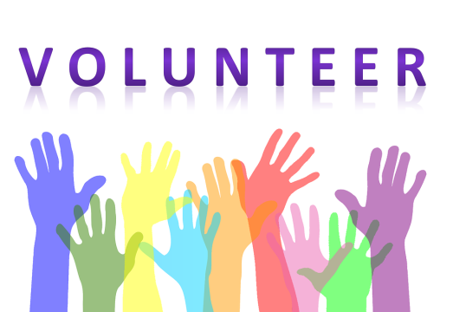
Volunteering Considerations
- Benefit? Why should I volunteer?

- What outcome am I hoping for?

- What is the ideal volunteer situation for me?

- Do I have the financial means to support myself if I volunteer?

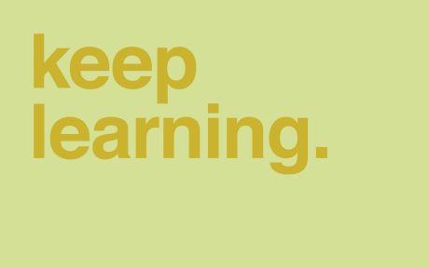
Is More Education Right For Me?
- Benefit? Why should I go to school?

- What outcome am I hoping for?

- What is the ideal education situation for me?

- What is my financial situation?

- What resources do I have to assist me?

